LOAN APPROVAL

PREDICTION

PROJECT WORK

**SUBMITTED BY,**

**ANANTHA KRISHNAN.P**

**INTRODUCTION**

**Aim:** To determine the loan approval system using machine learning algorithms.

.

###### Synopsis:

Loan approval is a very important process for banking organizations. The systems approved or reject the loan applications. Recovery of loans is a major contributing parameter in the financial statements of a bank. It is very difficult to predict the possibility of payment of loan by the customer. In recent years many researchers worked on loan approval prediction systems. Machine Learning (ML) techniques are very useful in predicting outcomes for large amount of data. In this paper different machine learning algorithms are applied to predict the loan approval of customers..In this paper, various machine learning algorithms that have been used in past are discussed and their accuracy is evaluated. The main focus of this paper is to determine whether the loan given to a particular person or an organization shall be approved or not.

**SYSTEM ANALYSIS**

###### EXISTING SYSTEM

The enhancement in the banking sector lots of people are applying for bank loans but the bank has its limited assets which it has to grant to limited people only, so finding out to whom the loan can be granted which will be a safer option for the bank is a typical process. In existing process, they are use RF algorithm in loan approval system. But the efficiency and accuracy was pretty low. Already banks are provide online transaction system, online bank account opening system, etc,. But there is no loan approval system in the banking sector. Then now we create a new system for loan approval. So now we move on to the proposed system.

###### PROPOSED SYSTEM

The proposed model focuses on predicting the credibility of customers for loan repayment by analyzing their details. The input to the model is the customer details collected. On the output from the classifier, decision on whether to approve or reject the customer request can be made. Using different data analytics tools loan prediction and there severity can be forecasted. In this process it is required to train the data using different algorithms and then compare user data with trained data to predict the nature of loan. The training data set is now supplied to machine learning model; on the basis of this data set the model is trained. Every new applicant details filled at the time of application form acts as a test data set. After the operation of testing,model predict whether the new applicant is a fit case for approval of the loan or not based upon the inference it conclude on the basis of the training data sets. By providing real time input on the web app. In our project, Logistic Regression gives high accuracy level compared with other algorithms. Finally, we are predicting the result via data visualization and display the predicted output using web app using flask.

###### HARDWARE AND SOFTWARE SPECIFICATION

**HARDWARE REQUIREMENTS**

* + - * Hard disk : 500 GB and above.
      * Processor : i3 and above.
      * Ram : 4GB and above.

###### SOFTWARE REQUIREMENTS

* + - * Operating System : Windows 10
      * Software : python
      * Tools :Anaconda (Jupyter Note Book IDE)

###### TECHNOLOGIES USED

* Programming Language: Python.

**Architecture Diagram:**



Dataset Preprocessing



User Input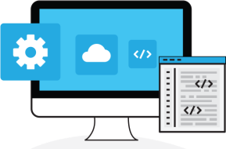

#### Web app



###### 

**DATA FLOW DIAGRAM:**

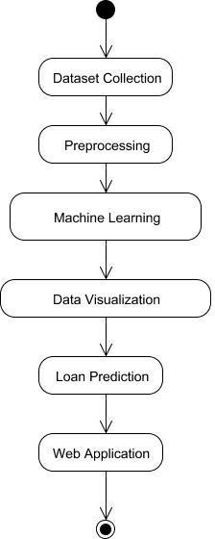

**RELATIONAL DIAGRAM:**

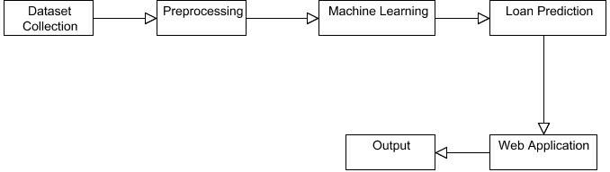

**PROGRAM DESIGN:**

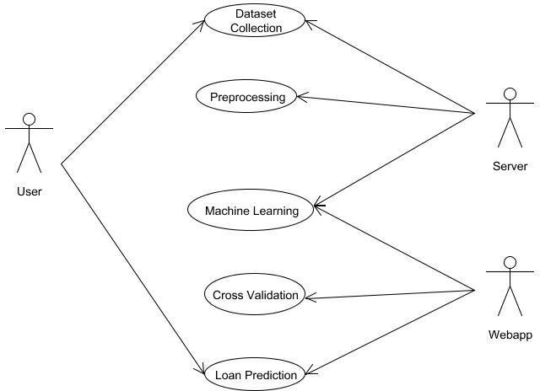

**TESTING**

Testing is a process of executing a program with the intent of finding an error. A good test case is one that has a high probability of finding an as-yet –undiscovered error. A successful test is one that uncovers an as-yet- undiscovered error. System testing is the stage of implementation, which is aimed at ensuring that the system works accurately and efficiently as expected before live operation commences. It verifies that the whole set of programs hang together. System testing requires a test consists of several key activities and steps for run program, string, system and is important in adopting a successful new system. This is the last chance to detect and correct errors before the system is installed for user acceptance testing.

The software testing process commences once the program is created and the

documentation and related data structures are designed.

Otherwise the program or the project is not said to be complete. Software testing is the critical element of software quality assurance and represents the ultimate the review of specification design and coding. Testing is the process of executing the program with the intent of finding the error. A good test case design is one that as a probability of finding an yet undiscovered error.

###### PROGRAM TESTING:

The logical and syntax errors have been pointed out by program testing. A syntax error is an error in a program statement that in violates one or more rules of the language in which it is written. An improperly defined field dimension or omitted keywords are common syntax error. These errors are shown through error messages generated by the computer. A logic error on the other hand deals with the incorrect data fields, out-off-range items and invalid combinations. Since the compiler s will not deduct logical error, the programmer must examine the output. Condition testing exercises the logical conditions contained in a module. The possible types of elements in a condition include a Boolean operator, Boolean variable, a pair of Boolean parentheses A relational operator or on arithmetic expression. Condition testing method focuses on testing each condition in the program the purpose of condition test is to deduct not only errors in the condition of a program but also other a errors in the program.

###### REFERENCES

1] Amruta S. Aphale and R. Prof. Dr. Sandeep. R Shinde, “Predict Loan Approval in Banking System Machine Learning Approach for Cooperative Banks Loan Approval”, International Journal of Engineering Trends and Applications (IJETA), vol. 9, issue 8, 2020)

1. Loan Prediction Using Ensemble Technique, International Journal of Advanced Research in Computer and Communication Engineering Vol. 5, Issue 3, March 2016
2. Exploratory data analysis https://en.wikipedia.org/wiki/Exploratory_data_analysis
3. Pandas Library https://pandas.pydata.org/pandas-docs/stable/

**conclusion**

That in system Data cleansing and processing ,imputation of missing values,experimental analysis of datasets,model construction, model evaluation,and model testing are all in the prediction process.The highest level of accuracy on the data set,based on the Training model